The University of Sheffield

**Development of an Agent-based Model Capturing Cellular**

**Interactions Associated with Heart Attack**

Harrison Paul Cooper

Supervised By:

Dr. Dawn Walker

COM3610

<Date>

This report is submitted in partial fulfilment of the requirement for the degree of MComp Computer Science with a Year in Industry by Harrison P. Cooper

Signed Declaration

All sentences or passages quoted in this report from other people's work have been specifically acknowledged by clear cross-referencing to author, work and page(s). Any illustrations which are not the work of the author of this report have been used with the explicit permission of the originator and are specifically acknowledged. I understand that failure to do this amounts to plagiarism and will be considered grounds for failure in this project and the degree examination as a whole.

Name:  Harrison Paul Cooper

Signature:

Date:

Abstract

Ageing is believed to be the largest contributor to the deterioration of the wall lining the inside of our blood vessels. Ageing is dictated by a series of rules which produce emergent behaviours between cells. This can be modelled with the cells as agents to provide a deeper understanding of cell interactions during healing.

Through thorough reading, several parameters have been found that can form a basis for the

testing and experimentation of the software.

This report goes through the current state of the art in agent based modelling, comparing relevant software and potential modifications that could be made to them for this project.

Acknowledgements

I would like to take the time to give my thanks to Dr Dawn Walker for her continued encouragement and expert advice throughout this challenging project.

Glossary

Eukaryotic Cell: A biological cell with a membrane-bound nucleus

Endothelial Cell: Cells that line blood vessels inner surfaces

In Vitro: Experimentation outside a living organism (in glass)

Quiescence: A state of cellular inactivity

Senescence: Deterioration of functional cellular characteristics

Telomere: A segment of DNA at the end of chromosomes

Pro-atherosclerotic: Pertaining to atherosclerosis, which is when arteries thicken from fatty

deposits.

Contents

Title page i

Signed Declaration ii

Abstract iii

Acknowledgements iv

Glossary v

Contents vi-vii

**1 Introduction 1**

1.1 Background Information 1

1.2 Aims and Objectives 1

1.3 Constraints 1

1.4 Summary of Report 1-2

**2 Literature Review 2**

2.1 The Endothelial Cell Cycle 2

2.2 Ageing 3

2.3 Senescent Cells 3

2.4 Atheroprone Sites 3

2.5 Methods of Modelling 4

2.6 Review of Agent Based Software 4-5

**3 Requirements and Analysis 5**

3.1 Aims and Objectives 5

3.1.1 Objectives 5

3.1.2 Parameters 5

3.1.3 Rules 6

3.2 Areas not Covered 6

3.3 Risk Analysis 6-7

3.4 Evaluation and Testing 8

Testing Strategy?

User Evaluation?

Licencing?

Functional Requirements

Non-functional requirements

**4 Design 8** Implementation Selection  
  
 Methods of Choice

Agents

General Cell

Endothelial Cell

Quiescent Cell

Senescent Cell  
  
Environment

… Each type of starting cell has a random xyz in range ij …   
  
Rules

General Cell Rules

Apoptosis

Endothelial Rules

Turnover  
  
Senescence  
  
Migration  
  
Quiescence

Mitosis

Stages

Growth

Quiescent Rules

Turnover

Senescence

Movement  
  
Proliferation

Growth

Senescence

Senescent Rules

Turnover   
  
Movement

Growth

Output

Confluence Detection

Scratch Creation

**5 Implementation and Testing**

**5.1 Implementation**

**5.1.1 EC Mitosis**

**5.1.2 EC Quiescence**

**5.1.3 EC Senescence**

**5.1.4 Command Line Interface**

**5.2 Testing**

**5.2.1 Unit Testing**

**5.2.2 Verification of ABM System**

**5.2.3 User Testing**

**6 Results and Discussion** 6.1 Completed Software and Documentation  
  
 6.2 User Story Analysis  
  
 6.3 Analysis of Underlying CellABM

6.3.1 Findings

6.3.2 Program Efficiency and Runtime Analysis

6.3.3 Goals Achieved  
  
 6.3.4 Further Work

**7 Conclusions**

**References 14-15**

**1 Introduction**

1.1 Agent Based Models

1.1 Background Information

The cells which line our blood vessels are called Endothelial cells (EC), which form a layer known as the Endothelium. This layer of cells can repair itself after injury, which is essential to good health, however, the repair process becomes slower with age due to an increased number of larger cells which actively hinder the healing.

These cells are generally in a confluent layer, therefore a larger number of cells are no longer dividing, however, when they’re wounded, such as an atheroma, the confluence is broken and the cells leave this phase to continue dividing, repairing the damaged tissue. This process is slower in elderly patients due to the increased number of larger cells, or if the same area is damaged a second time after repair. This is due to scar tissue being less capable of mitosis and repair.

1.2 Aims and Objectives

The main aim of this project is to estimate the affect ageing has on the ability for blood vessels to heal after being scratched. The implications of this project will help professionals further understand the process of wound healing and to provide further insights into the conditions affecting the deadly disease atherosclerosis, which can lead to strokes and heart attacks.

The way the main aim will be implemented requires the development of an agent based model (ABM) to encapsulate the key behaviours associated with ECs, including: cell proliferation, apoptosis, and senescence. This model will record the time taken for the wound to repair itself, and observe any emergent behaviour that takes place through the mitosis and movement of the cells, at varying ages. For the basis of producing a software solution, I will be looking at the benefits different types of modelling possess, such as Cellular Automata (CA) and Agent Based Modelling (ABM). Then, I’ll be building on top of current software frameworks, which already provide basic logic, by giving the agents and environment differing behaviours.

I’ll be observing the difference between elderly and younger cells to see how much, if any, age affects repair time.

This project has ample room for expansion; some of these aims include: modelling the problems associated when the endothelium layer doesn’t sufficiently repair in time, and the effect on endothelium repair after successive tears (allowing significant scar tissue to build up), showing the differences in speed and process of the repair. It would also be beneficial to model a more realistic vessel shape as the blood flow turbulence has a dramatic effect on healing ability.

1.3 Constraints

For the initial version of the system that will be developed, the model will be restricted to a single monolayer of ECs in a 2D plane. There will also be restrictions on the number of cells modelled due to the environment size, and these cells will have no interaction with other tissues.

1.4 Summary of Report

Over the next few pages, I’ll summarise the literature read to date, picking out any data that could be used as parameters, go through the current state of several relevant software and how they can be adjusted to this project. Next, we’ll discuss in detail the aims and objectives, what will not be covered and why, and any experiments or tests that will be carrying out at the end of the project. Finally, I end on a conclusion on what’s been found so far, my achievements to date and a project plan to take through semester 2.

**2 Literature Review**

Our blood vessels inner most wall is called the endothelium and is comprised of ECs. These cells have certain behaviours which lead them, over time, to decrease their rate of healing. There are several ways software can be used to model this behaviour to better understand and predict undesirable affects, such as atheroma formation. The way this project tackles modelling is an agent based approach, where each EC is simulated and can move around the model independently.

2.1 The Endothelial Cell Cycle

Firstly, it’s important to fully understand the mechanisms by which our ECs divide and any biological factors that can change its behaviour. ECs are a specific type of Eukaryotic Cell that line our blood vessels. When these cells are healthy, they secrete molecules, such as hormones, into the blood stream to maintain homeostasis [1]. This is vital as it helps fend off disease progression, keeping the individual healthy.

EC’s, like other Eukaryotic Cells undergo several distinct phases during replication as shown in the diagram below, however have another stage they can enter before S Phase.

Figure 2.1: Phases of eukaryotic cell cycle [2]

Stages G1, S and G2 are called Interphase; this is the time when the cell is increasing in size, and the lengths of time in each stage are proportional to their relative lengths. As shown in the figure, during S phase, the DNA is replicated forming a copy of itself which moves onto M phase (mitosis), when the enlarged cell splits into 2 identical daughter cells [3]. The length of time for a normal Eukaryotic Cell to undergo proliferation is around 24 hours, with 1 hour of that being the M phase, therefore 23 hours (96%) of the time is during cell growth and DNA replication, during which time the cell grows to be about twice its size [3].

However, for ECs there is another cycle between the G1 and S phase. This is called the G0 phase and generally known as the quiescence state. This is a state of inactivity, usually induced when EC proliferation is no longer required. If there is a stressor, such as a decrease in external pressure due to the ECs spreading out or moving, the quiescent cell can move out of G0 back into the normal eukaryotic cell cycle [4]. However, if the EC stays in the quiescent state for too long, it’s possible for it to develop into a senescent cell over time where it will never return to the normal cycle [5].

In general, ECs are long, flat cells around 5-10μm in radius and 1-2μm wide [6].

2.2 Ageing

An important factor that contributes to pro-atherosclerotic changes to the endothelium is ageing [7]. The number of times an EC can divide is limited, and once reached the cell goes into growth arrest, known as senescence [8]. This is due to the shortening of the ECs telomeres (the end parts of DNA) by 50-200 base pairs each time the cell proliferates. Once these telomeres are shorter than a critical length, the cell becomes senescent. The number of times a cell can proliferate is known as the Hayflick Limit, and for normal ECs is around 50 [9].

2.3 Senescent Cells

It has been noted the senescent ECs have several characteristics which differ them from normal ECs. Fir st of all, they are unable to undergo mitosis and have a turnover rate of around 3 years [7], they become enlarged after entering this state [10] and slow down surrounding ECs. Warboys suggests that senescent ECs could be the main contributor and initiator of atherosclerosis. In vitro, it has been seen that senescence in the ECs increases during a turbulent, disturbed flow, from 1% of EC being senescent using a 13 dynes/cm2 uniform flow compared to just over 2% senescent EC when exposed to a flow fluctuating between +/- 5 dynes/cm2 at 1Hz. It’s also noted that for these two categories, the number of multinucleate cells with a diameter > 100µm increased from 0.5% to 1.5. This increase in number of senescent ECs is believed to be due to an increase turnover rate of ECs at these turbulent atheroprone sites. Meaning that this increased level of proliferation should be considered when developing my senescent cell model. It can also be hypothesised here that in general, over time, more cell proliferation will occur and thus there will be an increase in the total number of senescent cells within the environment.

Another important fact Warboys reveals is that due to the size of the senescent ECs, this has a detrimental effect to the speeds of its neighbouring cells, acting as a blockage, and slowing them down. This can hinder wound healing as it will take longer for healthy mitotic ECs to fill the gap. As mentioned above, there’s is also an increase in the number of senescent cells over time, therefore I expect my model to show that with age, it takes longer for any wounds to heal.

2.4 Atheroprone Sites

Not all ECs within our blood vessel have the same physiological behaviours; this is due to the differing environmental factors within the vessels, discussed above. This leads to parts of our blood vessels under going higher levels of injury than others. In fact, the main disease this project is aimed at further understanding, atherosclerosis, is rather specific, and can be most commonly be found at the bends or branches of arterial trees [11]. These bends and branches are known as atherosusceptible sites, which have enhanced proinflamitory activation, increasing rate of proliferation [11]. These atherosusceptible sites therefore have a higher rate of injury and cell turnover compared to EC at atherprotected sites [12, 13, 14]. Analysis by Chaudhury et al showed that the ECs at Atheroprone sites express proteins that respond to lipopolysaccharides by priming for apoptosis and proliferation [11]. They also state that wherever JNK1 is active is where apoptosis and EC turnover occur in arteries.

I will therefore be looking at branches and bends within my model as they are the areas where there is the highest level of turbulence and concentration of JNK; leading to the greatest injury of the endothelium wall. Which, in turn has the greatest concentration of EC apoptosis and proliferation.

2.5 Methods of Modelling

There are two clear options for modelling the interactions between ECs and senescent cells. Cellular automata (CA) is an orthogonal grid of similar cells that interact with their neighbouring cells. Its advantages are that runtime is extremely quick and it can produce complex macro-scale emergent behaviour of the interacting cells [15]. However, the disadvantages are that due to the orthogonal grid, cells are fixed in place, unable to move; this is very much a simplification of the project as ECs move around on the endothelium to fill gaps and is an important factor for wound healing. Another disadvantage of CA is that it can only model local interaction between neighbouring cells, therefore any change further away from the cell won’t be noticed until it cascades down the subsequent neighbouring cells over several iterations

Whereas an Agent Based Model is a dynamic system of interacting agents. This dynamic property is crucial in producing realistic emergent behaviours as it more closely resembles what occurs in nature. The downside is, that due to the free movement of the cells, expensive calculations must be implemented to resolve overlapping and collisions in more accurate systems, introducing scalability issues. However, there are several methods out there for reducing the time taken; Endotheliome, an ABM created by Dr. Dawn Walker [16], embedded their overlap logic as C within their MATLAB code. This is also possible within python [17]. For these reasons, I believe it’s best to complete this project using an Agent Based Model.

2.6 Review of Agent Based Software

So far, I’ve tested two computer programs that use agent based modelling to allow for the type of emergent biological behaviours I’m looking for. The first program is SPARK which is a lightweight and efficient tool for CA. Being so lightweight, Spark is very capable of modelling the number of cells I would require for this project; in fact, it can simulate a grid of 101x101 with 10201 cells in real time. Its programs are written in SPARK-PL which is translated into Java source code, meaning a significant amount of time will be required to learn the new language. Another downside is that being a CA the ECs are embedded into the endothelial matrix (the layer the cells sit on top) and therefore are unable to move around the system, and as explained above, this is a simplification of reality as ECs are constantly moving or shifting on top of the endothelium layer.

The other program is a python based ABM by Marziha Tehrani, a PhD student, called CellABM. It’s used to model the interactions between cancer cells and stem cells. It has several classes which allows the user to easily change the rules of each phase of the cell cycle along with the initial cell parameters, such as size, direction and speed. However at large cell numbers is rather slow and has no capabilities of interacting with the agents during the simulation.

There are three other software frameworks I’ve looked at, but not as in-depth as the two described above; they are: Net Logo, Mason, and Repast.



Below, I have quantitatively summarised the strengths of each software in relation to each other. I use a scoring system between 1 (low) and 5 (high) and multiply that by the weight of each category. This gives a total showing the overall usefulness of the software.

|  |  |  |  |  |  |  |
| --- | --- | --- | --- | --- | --- | --- |
|  | | **Comparison of Software** | | | | |
| **Spark** | **CellABM** | **Net Logo** | **Mason** | **Repast** |
| **Method (CA or ABM)** | 0.1 | 1 | 5 | 5 | 5 | 5 |
| **Contact Resolution** | 0.2 | 1 | 4 | 2 | 2 | 3 |
| **Language** | 0.2 | 2 | 5 | 3 | 3 | 3 |
| **Interaction during simulation (GUI)** | 0.1 | 3 | 1 | 5 | 4 | 5 |
| **Speed** | 0.3 | 4 | 2 | 4 | 4 | 4 |
| **Familiarisation** | 0.1 | 3 | 5 | 1 | 1 | 1 |
| **Total** | 1 | 2.8 | 3.5 | 3.3 | 3.2 | 3.5 |

Table 2.1: Quantifying the differences between possible software

2.7 Cell Migration

* Very important to wound healing

2.8 Review of Current Published ABM systems

- I Could just move Epithelome to 2.6

2.9 Contact Inhibition and Confluence Detection

- Quite a few papers to reference here

**3 Requirements and Analysis**

- Explain separating programmed vs. emergent behaviour more coherently.

- More Specific Aims and Objectives

3.1 Aims and Objectives

The main aim of this project is to demonstrate and help professional understand further the affect ageing, and other physiological factors, has on the ability for a wounded area of ECs to repair itself. The main observation will be time taken for the ECs to divide and move into the gap of the wound, once more forming a confluent layer.

To facilitate the main aim, we’ve seen the benefits several current software have, to form the start of the project; however, they lack the correct logic or behaviours that occurs within blood vessels. Below, I outline the objectives, parameters, and rules that need to be met to produce an accurate and correct model.

3.1.1 Objectives:

1. Implementation of a basic EC class which instantiates each cell with a random size (within a range), a direction and a speed.
2. Implementation of a quiescent and senescent state to extend the EC class.
3. Implementation of confluence detection and simulation halting.
4. Implementation of wound creation and healing.

3.1.2 Parameters

These parameters have either been gained from literature review or are an educated guess which will be refined heuristically on the final product.

|  |  |  |
| --- | --- | --- |
| **Parameter Name** | **Data** | **Source** |
| EC diameter | 10-20μm | Literature Review |
| Senescent cell diameter | < 100μm | Literature Review |
| EC speed | N/A | Educated Guess |
| Senescent cell speed | 0 | Literature Review |
| EC direction | Random | Educated Guess |
| EC growth factor | 2 x during proliferation | Literature Review |
| Cell turnover | 50 times | Literature Review |
| EC turnover time | 24hrs | Literature Review |
| Senescent cell turnover time | 3 days | Literature Review |
| Time period | 7 hours | Educated Guess |

Table 3.1: Values associated with the parameters for the software.

3.1.3 Rules

|  |  |
| --- | --- |
| **Rule Name** | **Behaviour** |
| Mitosis | * Splitting enlarged EC into 2 equal sized half cells. |
| Apoptosis | * When turnover limit reached, enter * Remove cell from environment |
| Quiescence | * When no more proliferation possible, enter * When proliferation possible, exit * No mitosis |
| Senescence | * When cell turnover hit, enter * When cell has been quiescent for long enough, enter * Static * Enter cell growth * No mitosis * Cell turnover = 3 years |
| Collision Correction | * Adjust overlapping cells so they no longer are |
| Cell growth | * Double in size for ECs * Grow up to 10 times in size for senescent cells |

Table 3.2: Check-list of the behaviours each implemented rule should have.

3.2 Areas not Covered

Either due to time or computational constraints there are a few areas that this project will not be covering. Firstly, due to the lack of understanding the advanced Biology of the inner workings of ECs, I will be unable to implement all the of rules biologists have found that cause cellular senescence.

Another area I will not be covering are the multiple ways the endothelial monolayer gap can be filled during healing. I am only modelling the spreading of adjacent ECs into the gap due to the decrease in pressure caused by the lack of cells pushing back. The other ways the gap can be filled include: hyperplasia of existing endothelial cells and engraftment of circulating endothelial progenitor cells [7].

I am also assuming, that I am modelling ECs from a healthy person with a Hayflick limit of 50, ignoring deficiencies such as Werner syndrome which causes individuals to have a population growth of 53% and total replicative life span of 27% compared to normal cells [18].

I will not be creating a graphical user interface (GUI) for the user to change parameters on the fly in the simulation. All parameters will be set at the beginning of the simulation and shall remain unchanged. To observe the effect of the changing parameters, several simulations must be run with varying initial conditions.

3.3 Risk Analysis

I’ve included all the risks I believe are associated with my project below. I outline the nature of the risk, then give it a likelihood and impact score from 1 – 4, 1 being unlikely / negligible and 4 being very likely / project threatening then provide a mitigation plan to decrease severity.

|  |  |  |  |  |  |
| --- | --- | --- | --- | --- | --- |
|  | | **Likelihood** | | | |
| Very unlikely  1 | Unlikely  2 | Likely  3 | Very Likely  4 |
| **Impact** | Negligible 1 | 1 | 2 | 3 | 4 |
| Low 2 | 2 | 4 | 6 | 8 |
| Significant 3 | 3 | 6 | 9 | 12 |
| Catastrophic 4 | 4 | 8 | 12 | 16 |

Table 3.3: Risk Rating Matrix where Risk Rating = Likelihood x Impact

|  |  |  |  |  |
| --- | --- | --- | --- | --- |
| Risk Event | Likelihood | Impact | Risk Rating | Mitigation |
| Loss of developers’ code | 1 | 4 | 4 | Backups of the developers’ machine are take daily to an external hard-drive. The code will also be tracked on GitHub. |
| External event prevents progression | 2 | 3 | 6 | Careful project planning implementation of contingency plans if developer starts to fall behind. Some weeks are designed to have less work in case developer needs to catch up. |
| Optimistic project plan | 3 | 3 | 9 | Enough time must be given to the development of the software and is something that shouldn’t be rushed. Adjustment to project plan may be required if developer start to lag. |
| Completion of code hinders completion of dissertation | 2 | 4 | 8 | Enough time will be given to produce several drafts of the final dissertation in the project plan. |
| New functions not working with current software | 2 | 3 | 6 | Ensuring there are no compatibility issues and correct design practices are followed, such as the creation of UML diagrams showing function interaction. |
| Contact resolution scalability not fixed | 3 | 4 | 12 | Review of different software for contact resolution. Decreasing experiment area is a last resort to ensuring a confluence can be modelled. |
| Lack of accurate data | 4 | 3 | 12 | Continual reviewing of papers surrounding the topic for any extra hints. Otherwise a heuristic approach with several simulations should provide accurate results. |
| System too slow for use under standard conditions | 3 | 4 | 12 | Avoid implementation of nested loops, and constantly assess performance. Possibility of running simulation on Iceberg. |
| Requirements change during development | 1 | 3 | 3 | The code will be implemented in an Object Orientated manner, providing modularity of functions with little refactoring. |

Table 3.4: Risk identification, analysis and planned mitigations.

3.4 Evaluation and Testing

There are several tests that could be used to measure the success of the project once everything’s completed.

Test 1 would involve the variation of age and the subsequent measurement of change in time for the wound to heal. In order to vary age, as shown in the literature review, the number of starting senescent cells within the model will change, with younger patients having fewer senescent cells and elderly patients more. This test is paramount as it will be the main evidence used to answer the main aim.

Test 2 involves varying the wound size and observing the time taken for the wound to heal for each age group.

I will also produce system and unit test to ensure the program works as intended and any bugs found can be ironed out.

The evaluation of my work will include the results I gather from the tests above and comparing them against current literature showing blood vessel wound healing in vitro.

1. **Design**As seen above, there are several ways of developing an ABM to implement the requirements. In this chapter, the various methods will be laid out and evaluated, leading to a final decision.

**4. 1 Implementation Selection**

* + 1. **Methods of Choice**

**Method 1: Development of new SPARK program**

This would involve starting the system from scratch, beginning with developing an environment for the agents to interact on, followed by the implementation of each of the different cell states and their transitions. **Method 2: Redesigning CellABM**  
The work already carried out by Marziha Tehrani on CellABM can be built upon to include a new cell state, Quiescence. The current classes, StemCells and CancerCells can be refactored to Endothelial Cells and Senescent Cells. Keeping much of the old code handling: apoptosis, cell movement, cell movement and overlap correction.

* + 1. **Chosen implementation method**

- After developing smaller prototypes on each of these systems, and through thorough consideration, the clear choice was to develop the project using the existing framework from CellABM

Mention it is more important for the user of the system to have the

* 1. **An overview of Python and its Class System**Since the implementation will be driven using Cell_ABM, Python is the language of choice for this project. Python is very similar to other widely used languages such as Java and <> in that it is an Object Orientated Programming Language (OOP).
  2. **Class Diagrams**
  3. **Environment**At the beginning of the program, the user will define several key parameters used to initialise the environment. Notably, the size (in micrometres), the number of starting Endothelial Cells and the number of Starting Senescent Cells. This allows the user to define cell ratios for differing patient ages in accordance with the data found in <Find source of % senescent at each age>. The Environment class will then create the starting agents with a random set of parameters taken from a range given in the Literature Review <Insert number (2.x)>, and append them to a list of starting agents.

The cells will be placed on an orthogonal 2-D NumPy Matrix with x and y co-ordinates representing their relative locations within the simulation.

* 1. **Prototyping**4.4.1 Spark

4.4.2 mason  
4.4.3 CellABM  
4.4.4 Updated Class Diagram

* 1. **Theorised Program Flow**Below are the guides that will be followed during the development of the program. They provide the road map of how each class and function interacts with each other, leading to emergent behaviour of the cells. A quick overview of the cellular progression is given in Figure 4.5.1, showing how, generally, cells start out being normal Endothelial cells, then they can either move onto being Quiescent or Senescent. Quiescent cells are able to revert back to Endothelial cells or turn Senescent if they persist long enough. As shown, Senescent cells act as a sink, trapping the cell in that state until the end of the simulation.

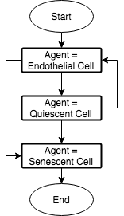

* + 1. **Cell_ABM**This flow chart shows how the overall program will run, generally solving the agents, correcting their overlap, and plotting a 2-D graph of agent locations. Finishing when the maximum number of iterations declared by the user has been reached.

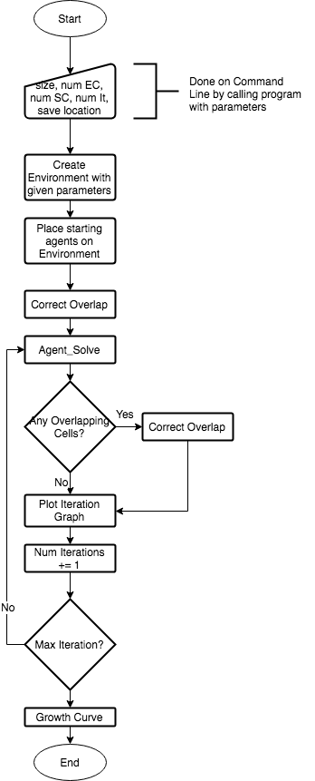

* + 1. **Cell Stages**

A more thorough plan of cell evolution is given below in figure 4.6.2.1. This shows the logic behind each of the cell stages, and how the cells progress with the simulation.

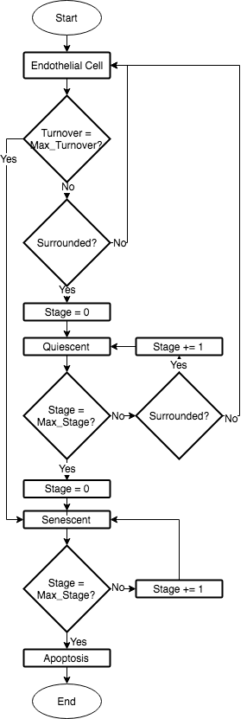

**4.5.3 Agent_Solve**This flow chart is missing logic about contact inhibition and confluence detection. This will be implemented in the final program flow chart. This flow chart is very similar to how Marziha left Agent_Solve. A Decision doesn’t have a No terminal (Stage = Max_Stage?)

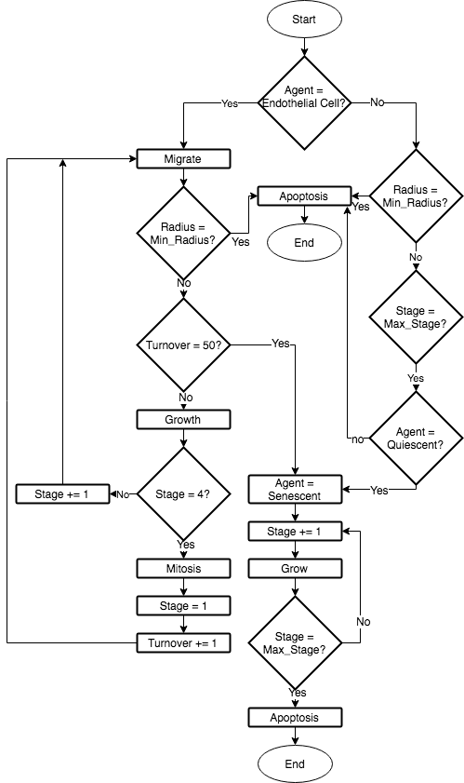

1. **Implementation and Testing**This section is concerned with the final process involved with implementing the background logic to produce the desired emergent behaviours. It will go through several of the rules outlined in 3.1.3 in detail. Then move onto testing of each of these rules, unit tests, and acceptance testing. 
   1. **Implementation**

Cell_ABM already had several sections of the program and logic developed; therefore, this chapter will focus on the areas of the program that we’re changed or developed to produce the required emergent behaviour and observations.  
Cell_ABM was originally written in Python 2.7 which was released in 2010 but is seen as the legacy version of the language, with Python 3.x being the supported language of choice for present and future programs [https://wiki.python.org/moin/Python2orPython3]. Thankfully many of the modules from Python 2.x have been ported over to Python 3.x, such as NumPy which Cell_ABM uses, leaving only basic refactoring of the code, including changing print statements to be functions. The change to Python 3.x was introduced to adjust certain aspects of the old Python program language to be simpler for new programmers to develop, and make it easier to read.

5.1.1 EC Mitosis

**5.1.2 EC Quiescence**

**5.1.3 EC Senescence**

**5.1.3 Command Line Interface**

**5.2 Testing**

**5.2.1 Unit Testing**

**5.2.2 Verification of ABM System**

**5.2.3 User Testing**

Illustrate “Coding Traps”

* + Nested for loops increase time complexity
* Highlight novel aspects to algorithms
* Done according to scheme within Analysis chapter and follow suitable model
* Functional testing
* User-acceptance testing
* Developed techniques evaluated against standard result set for calibration

**6 Results and Discussion**

**6.1 Completed Software and Documentation**  
The code developed in chapter 5 can be found on the code repository website GitHub at: https://github.com/HarrisonCooper/dissertation. The documentation on how to run the software can be found in Appendix <>. **6.2 User Story Analysis  
  
6.3 Analysis of Underlying CellABM  
  
6.3.1 Findings**  
  
**6.3.2 Program Efficiency and Runtime Analysis**  
  
**6.3.3 Goals Achieved**

* Degree to which findings support original objectives of project.

**6.3.4 Further Work**

* New areas of investigation
* Current part of work not completed

**7 Conclusion**

7.1 Conclusion

This survey and analysis started by outlining the biological processes that go on within an EC, allowing us to understand the rules behind the behaviours that cause wound healing to slow down with age. The research then went onto the various methods applicable to this project, finding an agent based approach to be best. A review of suitable software was conducted in table 2.1 showing CellABM and Repast to be equal in applicability. For this reason, during the beginning of semester 2, time will be given to see if the runtime of CellABM can be decreased; if not resorting to Repast is a viable option, although implementation of contact resolution is not desirable due to its complexity.

Several parameters and rules have been sourced to act as guidelines for the development of the program, however due to the uncertainty around the accuracy of this data, a heuristic approach will also be used throughout.

7.2 Progress

So far to date, I’ve managed to convert CellABM from python 2 in to python 3, basic comments to functions with the expectation of full documentation once the full system works and is tested. I’ve run several simulations of Marzihas’ code as shown below, with the area and number of iterations is the same across all tests at 0.1mm2 and 50 respectively. The program was run on a 2015 15” Mac Book Pro with a 2.8 GHz Intel Core i7 and 16GB 1600 MHz DDR3 memory.

|  |  |  |  |  |
| --- | --- | --- | --- | --- |
|  | **Test 1** | **Test 2** | **Test 3** | **Test 4** |
| **Number of Cancer Cells at Start** | 10 | 100 | 0 | 200 |
| **Number of Stem Cells at Start** | 10 | 200 | 500 | 300 |
| **Total Number of Cells at Start** | 20 | 300 | 500 | 500 |
| **Number of Cancer Cells at End** | 18 | 176 | 0 | 368 |
| **Number of Stem Cells at End** | 17 | 304 | 774 | 476 |
| **Total Number of Cells at End** | 35 | 480 | 774 | 844 |
| **Difference in Number of Cells** | 15 | 180 | 274 | 344 |
| **Time Taken (hours)** | 0.017 | 0.502 | 1.308 | 2.332 |

Table 7.1: Time taken to run CellABM with varying starting parameters.

This table shows us a possible drawback to CellABM, which is the computational power required. As shown for Test 4 it took 2.332 hours to model a total of 500 initial cells. Scaling this up to 1mm2 would therefore take a significant amount of time longer to even form a confluence, let alone the wound healing. This is down to the runtime of the overlap.py class, which is used to correct any overlapping of cells caused by mitosis or movement. The nested for loops used to iterate through each cell in turn means the time taken for the program to compute is at least Ο(n2). This is a scalability issue, as when I increase the area of the environment, the overlap class won’t be able to keep up with the increase in number of cells. However, this outcome may not be as adverse as it seems since each cell in CellABM is fixed at 3μm in diameter, whereas the ECs will be around 5-10μm in diameter and the senescent cells will be around 50-100μm. This means that overall, my simulation will have fewer cells than what CellABM models, reducing the scalability risk slightly.

Another downside is that Marzihas code doesn’t implement any cell growth, and each cell is the same diameter as every other cell for the whole simulation. This is a simplification and would not provide a realistic model of ECs.

This program is useful as it automatically outputs a graph showing the growth of each cell type over time, shown below. This can be used in my application to determine the rate of time required for the wound to heal with different starting parameters.

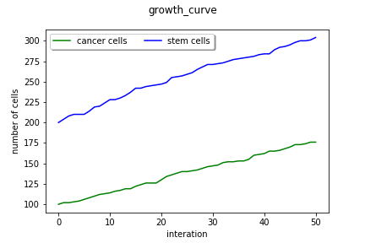

Figure 7.1: Taken from running CellABM with 0.1mm2 area, 100 cancer

cells and 200 stem cells.

CellABM also outputs a 2D and 3D image of environment each iteration, showing the movement of the cells over time, and demonstrate the emergent behaviours of wound healing with age. I can use this to demonstrate my models emergent behaviours such as stopping mitosis and entering quescence once a confluence is formed, visualising the shape and size of the wound, and how the wound is healed.

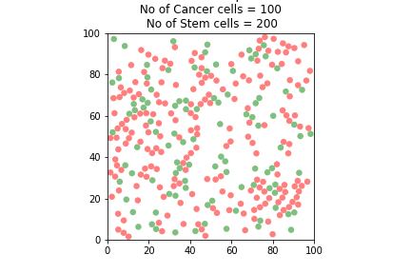

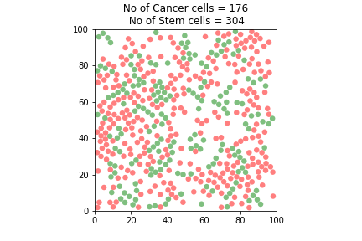

Figures 7.2 and 7.3: Taken from running CellABM with 0.1mm2 area, 100 cancer cell

and 200 stem cells, showing the initial and final iterations.

I have also been experimenting another software that was mentioned in the literature review, Spark. So far, I’ve managed to get spark running on my machine, gone through the example exercises provided and looked at the documentation [19]. The exercises modelled 10201 cells and their behaviours in real time; the limitation being that the cells are unable to move around, thus decreasing accuracy.

References

[1] Pearson, J. (2000). Normal endothelial cell function. *Lupus*, 9(3), pp.183-188.

[2] Ncbi.nlm.nih.gov. (2017). *Figure 14.1, Phases of the cell cycle - The Cell - NCBI*

*Bookshelf*. [online] Available at:

https://www.ncbi.nlm.nih.gov/books/NBK9876/figure/A2435/?report=objectonly

[Accessed 3 Dec. 2017].

[3] Cooper, G. (2000). *The cell*. Washington, D.C.: ASM Press.

[4] Cell Proliferation. (1991). *Index medicus*, [online] 24(1). Available at:

http://onlinelibrary.wiley.com/journal/10.1111/(ISSN)1365-2184 [Accessed 3 Dec.

2017].

[5] En.wikipedia.org. (2017). *G0 phase*. [online] Available at:

https://en.wikipedia.org/wiki/G0_phase [Accessed 3 Dec. 2017].

[6] Lab.anhb.uwa.edu.au. (1998). *Blue Histology - more about Endothelial Cells*. [online] Available at: http://www.lab.anhb.uwa.edu.au/mb140/moreabout/endothel.htm [Accessed 27 Nov. 2017].

[7] P.Brandes, R. (2005). Endothelial Aging. *Cardiovascular Research*, [online] 66(2),

pp.286–294. Available at: https://doi.org/10.1016/j.cardiores.2004.12.027 [Accessed 3

Dec. 2017].

[8] Foreman, K. and Tang, J. (2003). Molecular mechanisms of replicative senescence in

endothelial cells. *Experimental Gerontology*, 38(11-12), pp.1251-1257.

[9] Senescence.info. (2017). *Cellular Senescence: The Hayflick Limit and Senescent and*

*Aging Cells*. [online] Available at: http://www.senescence.info/cell_aging.html [Accessed

3 Dec. 2017].

[10] Warboys, C., de Luca, A., Amini, N., Luong, L., Duckles, H., Hsiao, S., White, A., Biswas, S., Khamis, R., Chong, C., Cheung, W., Sherwin, S., Bennett, M., Gil, J., Mason, J., Haskard, D. and Evans, P. (2014). Disturbed Flow Promotes Endothelial Senescence via a p53-Dependent Pathway. *Arteriosclerosis, Thrombosis, and Vascular Biology*, [online] 34(5), pp.985-995. Available at: http://atvb.ahajournals.org/content/suppl/2014/03/20/ATVBAHA.114.303415.DC1.html [Accessed 26 Nov. 2017].

[11] Chaudhury, H., Zakkar, M., Boyle, J., Cuhlmann, S., van der Heiden, K., Luong, L., Davis, J., Platt, A., Mason, J., Krams, R., Haskard, D., Clark, A. and Evans, P. (2010). c-Jun N-Terminal Kinase Primes Endothelial Cells at Atheroprone Sites for Apoptosis. *Arteriosclerosis, Thrombosis, and Vascular Biology*, [online] 30(3), pp.546-553. Available at: http://atvb.ahajournals.org/cgi/content/full/30/3/546 [Accessed 20 Nov. 2017].

[12] Gerrity, R., Richardson, M., Somer, J., Bell, F. and Schwartz, C. (1977). Endothelial cell morphology in areas of in vivo Evans blue uptake in aorta of young pigs. *Am J Path*, (89), pp.313-335.

[13] Hansson, G., Chao, S., Schwartz, S. and Reidy, M. (1985). Aortic endothelial cell death and replication in normal and lipopolysaccharide-treated rats. *Am J Pathol*, (121), pp.123-127.

[14] Hu, Y., Foteinos, G., Xiao, Q. and Xu, Q. (2008). RAPID ENDOTHELIAL TURNOVER IN ATHEROSCLEROSIS-PRONE AREAS COINCIDES WITH STEM CELL REPAIR IN APOE-DEFICIENT MICE. *Atherosclerosis*, 199(2), p.467.

[15] Pavelka, J., Tel, G. and Bartosek, M. (2000). *SOFSEM'99 - Theory and Practice of*

*Informatics*. New York: Springer.

[16] Walker, D., Hill, G., Wood, S., Smallwood, R. and Southgate, J. (2004). Agent-Based

Computational Modeling of Wounded Epithelial Cell Monolayers. *IEEE Transactions*

*on Nanobioscience*, 3(3), pp.153-163.

[17] Docs.python.org. (2017). *1. Extending Python with C or C++ — Python 3.6.3*

*documentation*. [online] Available at:

https://docs.python.org/3/extending/extending.html [Accessed 3 Dec. 2017].

[18] Salk, D., Bryant, E., Au, K., Hoehn, H. and Martin, G. (1981). Systematic growth

studies, cocultivation, and cell hybridization studies of Werner syndrome cultured skin

fibroblasts. *Human Genetics*, 58(3), pp.310-316.

[19] Pitt.edu. (2017). *SPARK - Simple Platform for Agent-based Representation of Knowledge*.

[online] Available at: http://www.pitt.edu/~cirm/spark/documentation.html [Accessed 4 Dec.

2017].